An Artificial Intelligence Project Report
MEDIKIOSK
AI and Rule-Based Clinical Intake and Diagnosis-Support System
By
305II072 | Aaradhy Anant Adhikari
305II075 | Sumeet Govind Jambhlikar
305II082 | Avadhoot Sachin Waman

TE (Computer Engineering)
Under the guidance of
Prof. R. B. Nawale

Sinhgad College of Engineering,
Vadgaon Bk., Pune-411041
Affiliated to Savitribai Phule Pune University, Pune.
2026-27

CERTIFICATE
This is to certify that the Artificial Intelligence Project Report entitled
MEDIKIOSK
AI and Rule-Based Clinical Intake and Diagnosis-Support System
Submitted by
305II072 | Aaradhy Anant Adhikari
305II075 | Sumeet Govind Jambhlikar
305II082 | Avadhoot Sachin Waman
Has successfully completed his/her Artificial Intelligence Project under the supervision of Prof. R. B. Nawale for the partial fulfilment of Bachelor of Engineering Computer Engineering for academic year 2026-27 of Savitribai Phule Pune University. This work has not been submitted elsewhere for any degree.

Prof. R. B. Nawale | Prof. S. R. Ganorkar
Guide | Head of Department

Dr. S. D. Lokhande
Principal

MediKiosk
An AI and Rule-Based Clinical Intake, Diagnosis-Support and Care-Navigation System
Live demo: https://medikiosk.vercel.app/
Source code: https://github.com/AaradhyAdhikari/medikiosk
ABSTRACT
A typical Indian outpatient department gives each patient about two to three minutes with a doctor, and most of that time is spent asking the same history questions, in a language the patient may not speak comfortably. This project presents MediKiosk, a self-service web kiosk that interviews the patient before the consultation in any of seven Indian languages (Hindi, English, Marathi, Gujarati, Punjabi, Tamil and Telugu), by touch or by voice, reads the medical papers they bring, and hands the doctor a structured, verified history. Underneath, it is a hybrid expert system: a rule-based inference engine (red-flag triage, department routing and a medicine-safety checker covering allergies, duplicate medicines, contraindications and drug interactions) works with large-language-model components that draft the clinical summary, suggest treatment options to the doctor, and give the patient an on-request AI health summary listing possible conditions, the specialist to see, likely tests, diet and medicines. Server-side rules decide what may reach the patient: no medicines in an emergency, doses only for a short over-the-counter list, and anything that clashes with the patient's record moved to a “do not take” list. The patient can then find nearby hospitals, clinics and chemists from OpenStreetMap and buy medicines through Indian online pharmacies. A continuous patient record, versioned prescriptions and a FHIR R4 export make the history follow the patient from one visit to the next.

1. INTRODUCTION
Clinical history taking is the most time-consuming part of a consultation and the part most damaged by crowding and language barriers. Patients forget medicines, cannot describe their pain in English, and lose their old prescriptions; doctors re-ask questions every visit and rarely have time to check a new prescription against everything the patient already takes. Expert systems address part of this by encoding medical knowledge as explicit IF-THEN rules that are easy to inspect and explain, while modern language models can read free text and handwriting and write fluent summaries.
This project combines the two. MediKiosk runs in a browser on a hospital kiosk or the patient's own phone. The patient answers a short, adaptive interview; the system raises red flags immediately, routes the patient to the right department, summarises the history for the doctor, checks prescriptions for safety, and gives the patient a clear next step, including where to go and what to buy.

2. OBJECTIVES
- Collect a complete clinical history before the consultation through an adaptive, multilingual, voice-enabled interview.
- Detect emergencies by rule, instantly and independently of any AI service.
- Route each patient to the correct hospital department using an explainable keyword-scoring rule base.
- Give the doctor a structured, editable AI summary, a continuous record across visits and AI-suggested treatment options.
- Check every prescription for allergies, duplicates, contraindications and drug interactions before it is approved.
- Give the patient an on-request AI health summary with medicines, tests, diet and nearby care, under safety guardrails.
- Keep every AI output separate from confirmed clinical decisions and attributable to the clinician who approved it.
- Deploy the system online so it can be used from any browser, with no installation.

3. PROBLEM STATEMENT
Given a patient arriving at an outpatient department, collect their symptoms, medical history, current medicines, allergies and documents in their own language; identify emergencies and the appropriate department; suggest possible diagnoses, tests and treatment for clinician review; check the final prescription for safety against the patient's record; and guide the patient to suitable care and medicines, without the AI ever presenting a guess as a confirmed diagnosis.

4. SCOPE AND LIMITATION
Scope: patient identification by mobile OTP or ABHA number; adaptive interview with a touch body-map; document scanning and reading; red-flag triage; department routing across 22 Ayurvedic and modern departments; doctor console with queue, record, prescription editor and AI options; patient AI health summary; nearby hospitals, clinics and chemists; buy links to online pharmacies; voice read-aloud with an on/off control; FHIR R4 export.
Limitations: the rule base is a curated list of well-known cautions, not a complete drug formulary; translations are machine-assisted and not yet checked by native speakers; AI output quality depends on the external model and key configured; facility data from OpenStreetMap is crowd-sourced and may be incomplete; ambulance dispatch, ABDM and hospital EMR integrations are mocked because they require formal approvals; the system has been tested only with synthetic patients and is not a certified medical device.

5. SYSTEM ARCHITECTURE
The project follows a three-layer architecture: a browser presentation layer, a Node.js application layer that holds the inference engine and the AI layer, and a data and external-services layer.
Layer | Technology | Responsibility
Patient kiosk | HTML, CSS, vanilla JavaScript, Web Speech API | Multilingual interview, voice input and output, AI health summary, nearby care, buy links
Doctor console | HTML, CSS, vanilla JavaScript | Queue, case view, patient record, prescription editor with live safety check, AI options
Application server | Node.js (built-in http, no framework) | REST API, sessions, inference engine (rules), AI orchestration, FHIR bundle, nearby search
AI layer | Groq, Mistral, Anthropic Claude (fallback chain) | Clinical summary, document reading, treatment options, patient summary
Data | Firebase Realtime Database and Storage | Patients, visits, prescriptions, record corrections, scanned documents
External APIs | Bhashini, OpenStreetMap Nominatim, SMS and email gateways | Indian-language voice, facility search, OTP and emergency alerts
Hosting | Vercel | Public deployment

Workflow: the patient answers the interview on the kiosk; each answer is matched against the rule base, so an emergency is flagged at once; on submission the server routes the visit to a department, asks the AI for a clinical summary and prepares the patient's health summary in the background; the doctor opens the case, reviews the summary and the record, writes or adopts a prescription that is checked as it is typed, and approves it; the patient can open their summary, find nearby care and buy medicines.

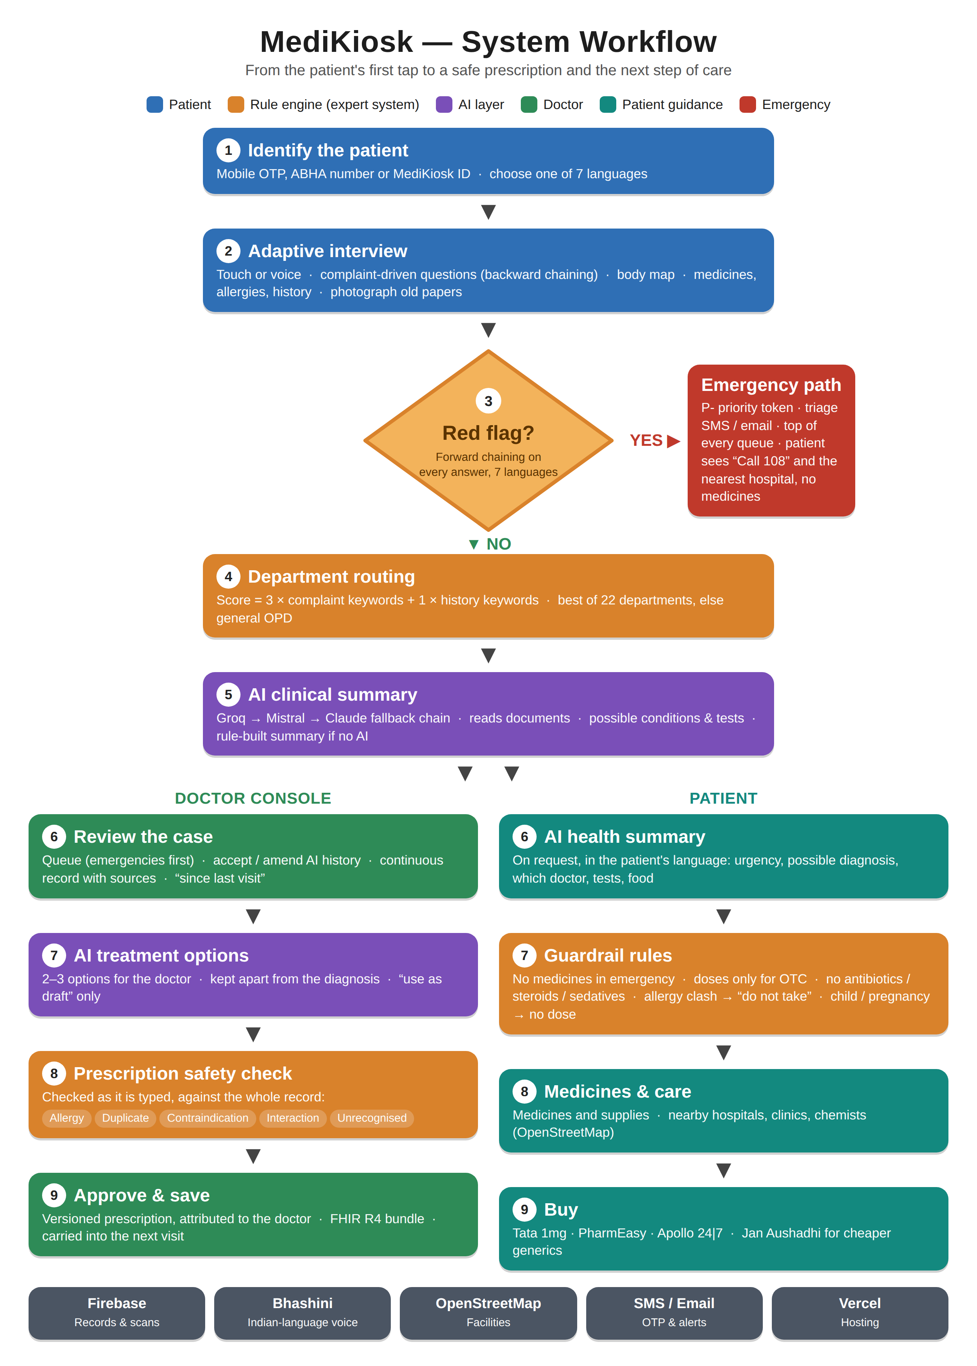
Figure 1: MediKiosk system workflow.

5.1 Project Structure
Folder or File | Purpose
server.js | Main server: routes, sessions, rule engine, record, prescriptions, AI calls, nearby search
ai.js | AI provider chain (Groq, Mistral, Claude) with automatic fallback
interactions.js | Knowledge base: 51 medicine agents, 31 interaction rules, allergy, duplicate and 12 contraindication rules
fhir.js | Builds the HL7 FHIR R4 document bundle for a visit
public/kiosk.html, kiosk.js | Patient kiosk: interview, summary, nearby care, voice
public/doctor.html, doctor.js | Doctor console: queue, case, record, prescription, AI options
public/questions.js | Question bank and complaint-driven branching
public/i18n.js, public/lang/ | Language registry and translation tables for seven languages
public/qr.js | Dependency-free QR encoder for the printed token slip
tools/ | Translation checker, review sheets, AI benchmark, demo-account script

6. METHODOLOGY

6.1 Adaptive Patient Interview
The interview starts from the chief complaint, spoken or tapped. The complaint is classified into a category (pain, skin, respiratory, stomach and others) by keyword matching in all seven languages, and only the questions a clinician would ask for that category are shown: onset, character, radiation, timing, aggravating factors, severity and the relevant review of systems. When AI is available, four or five extra follow-up questions are written for the specific complaint. Past illnesses, medicines, allergies and family history are always asked, and papers can be photographed and read.

6.2 Knowledge Base
The rule base is stored as data, not code paths, so it can be read and reviewed: red-flag phrases in seven languages; 22 departments, each with keywords (more than 200 are derived automatically from the translation files); 51 medicine agents with their pharmacological classes and common Indian brand names; and rules for interactions, allergy classes, cross-reactivity, duplicate therapy, contraindications and patient-facing medicine safety.

6.3 Forward Chaining (data-driven reasoning)
Forward chaining starts from the known facts and fires every rule whose IF-part is satisfied, adding conclusions until nothing new can be derived. MediKiosk uses it wherever facts arrive first and conclusions follow:
- Triage: IF an answer contains a red-flag phrase (chest pain, breathlessness, unconsciousness, seizure, bleeding) THEN mark the visit urgent, re-token it to the P- series, alert triage staff and move it to the top of every queue.
- Department routing: each complaint keyword adds to a department's score; IF the best score is at least 2 THEN route there, ELSE hold in general OPD.
- Medicine safety: IF a prescribed medicine belongs to a class the patient is allergic to THEN raise a high-severity allergy warning; IF two medicines share a class THEN flag duplication; and so on for every rule.
- Patient guardrails: IF the visit is an emergency THEN show no medicines; IF a medicine is not on the over-the-counter list THEN remove its dose.
Department score = 3 × (keywords found in the chief complaint) + 1 × (keywords found elsewhere in the history).

6.4 Backward Chaining (goal-driven reasoning)
Backward chaining starts from a hypothesis and works back to the facts it needs, asking for any that are missing. MediKiosk uses it in two places:
- Questioning: once the complaint suggests a hypothesis (for example a cardiac cause of chest pain), the interview asks the questions that would confirm or rule it out, such as radiation to the arm or jaw, sweating and breathlessness, instead of a fixed questionnaire.
- Safety queries: to answer the goal “is this medicine safe for this patient?” the checker looks for the facts the rules need (an allergy, a condition such as kidney disease or pregnancy, a medicine already taken) across every visit, and shows where each fact came from.

6.5 AI Layer
Large language models handle what rules cannot: reading handwritten prescriptions and lab reports, turning answers into a clinical summary, drafting treatment options and writing the patient's summary in their own language. Calls go through a chain of providers (Groq, then Mistral, then Claude) so that one provider's outage does not stop the system. Every model answer must be valid JSON; anything else is rejected and the rule-based fallback is used.

6.6 Hybrid Inference Algorithm
- Receive the patient's answers and documents.
- Forward-chain the red-flag rules; if any fires, raise the emergency immediately.
- Score the departments and route the visit.
- Ask the AI for the clinical summary and possible conditions; on failure, assemble the summary by rule.
- Prepare the patient's health summary and pass it through the guardrail rules.
- When the doctor prescribes, forward-chain the safety rules against the whole patient record.
- Store the approved prescription as a new version, attributed to the doctor.

7. IMPLEMENTATION

7.1 Backend (Node.js)
The server is a single Node.js process using only the built-in http module, so it runs the same on a laptop and as a Vercel serverless function. It exposes REST endpoints for identification and OTP, visits and submission, the patient record and corrections, prescriptions and their safety check, AI treatment options, the patient's health summary and nearby search. Sessions are signed cookies; data is persisted to Firebase with a local JSON fallback. Every API key is read from environment variables and is never committed to the repository.

7.2 Patient Kiosk
The kiosk is a large-text, touch-first single-page application. It offers seven languages, voice input, read-aloud with a voice on/off button, a touch body-map for locating pain, accessibility modes (large text, high contrast, audio guidance), a document camera, and a printed token slip with a QR code that opens the case at the doctor's desk.

7.3 Doctor Console
The console shows the live queue with emergencies on top, and for each case the AI history (to accept or amend), the “since the last visit” changes, the continuous patient record with the source of every fact, the AI assessment, AI treatment options and the prescription editor. Every warning names its source, and every AI suggestion is copied into the prescription only as a draft that the doctor must approve.

7.4 Patient AI Health Summary and Care Navigation
After the interview the patient can choose to open an AI health summary. It is prepared in the background as soon as the interview is submitted, so it is ready when asked for. It shows urgency, possible conditions marked more likely, possible or less likely, the specialist to see, tests a doctor may order, medicines, useful supplies, foods to eat and avoid, and emergency warning signs. Buy buttons open the medicine's search page on Tata 1mg, PharmEasy or Apollo 24|7 in a separate window; prescription medicines are marked as needing a prescription. Nearby hospitals, clinics and chemists are found by location or PIN code, with the Jan Aushadhi locator for cheaper generic medicines.
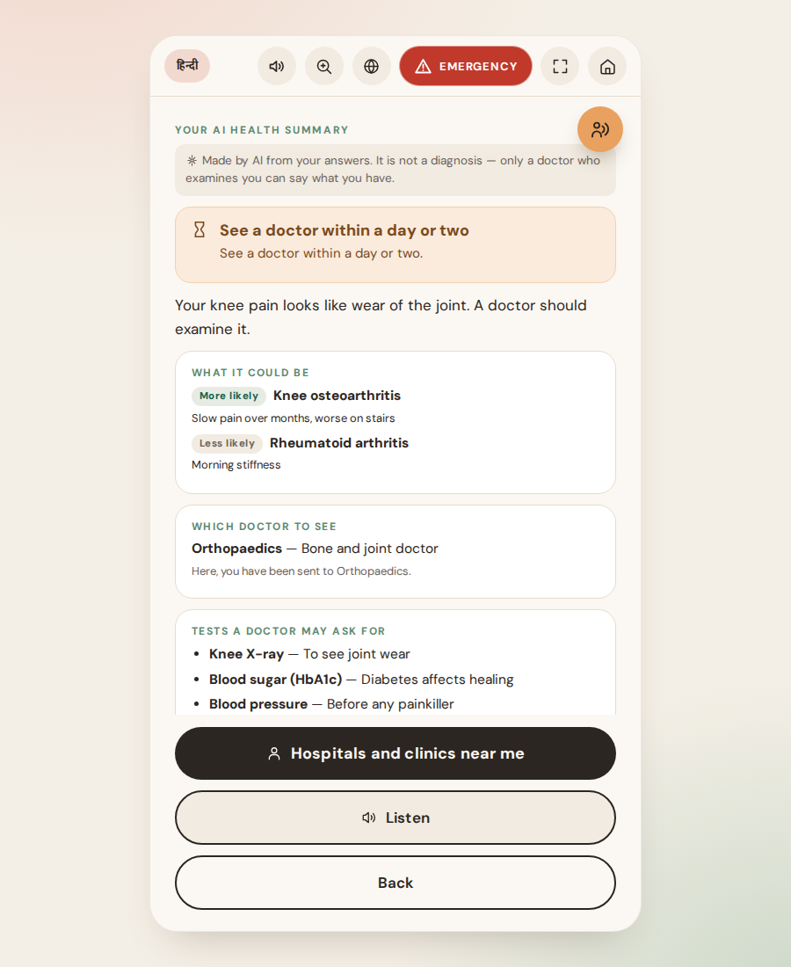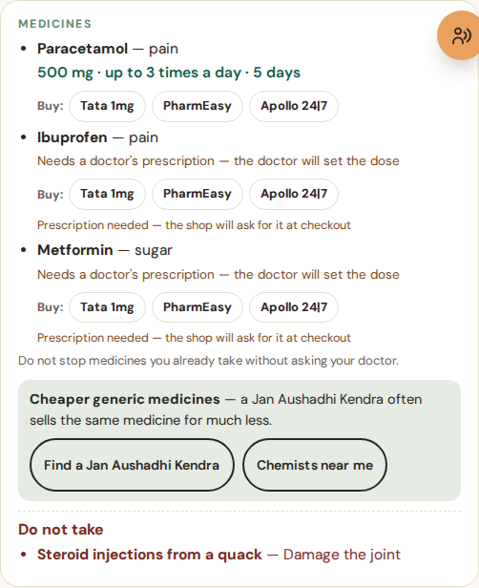
Figure 2: The patient's AI health summary — possible diagnosis, specialist, tests, and the medicines with buy links.

7.5 Deployment
The application is deployed on Vercel and is available at https://medikiosk.vercel.app/. The same code runs locally with a single command (node server.js); without any keys it still works, using rule-based summaries, on-screen OTP codes and the browser's own voices.

8. RULE BASED LAYER
The rule layer is the inference engine of the expert system. It runs on every request, needs no network, and produces a human-readable reason for every conclusion, so its output can always be explained to the doctor or the patient.
Rule | Condition | Action
Red flag | Answer contains an emergency phrase in any of seven languages | Mark urgent, P- token, alert triage, top of queue
Department routing | Department keyword score of at least 2 | Route to that department, else general OPD
Allergy | Medicine belongs to a class the patient is allergic to | High-severity warning; moved to “do not take” for patients
Cross-reactivity | Penicillin allergy with a cephalosporin; aspirin with an NSAID | Low or moderate warning
Duplicate therapy | Two medicines of the same class, or one already being taken | Moderate warning, “do not double up”
Contraindication | NSAID with kidney disease or ulcer; beta-blocker with asthma; ARB or statin in pregnancy | High-severity warning with the source of the condition
Drug interaction | One of 31 known pairs, e.g. anticoagulant with NSAID | Warning with the clinical note
Emergency guard | Visit is an emergency | No medicines or supplies shown; Call 108 and nearest hospital
Dose gate | Medicine is not paracetamol, ORS, antacid, antihistamine or vitamin | Dose removed; “needs a doctor's prescription”
Never to patient | Antibiotic, steroid, sedative, opioid, insulin or warfarin | Not shown to the patient at all
Pregnancy or child | Pregnancy mentioned, or age under 12 | All doses removed
Unrecognised medicine | Medicine not in the knowledge base | Listed as “check these yourself”, never shown as safe

Final result = rule conclusions (always applied) + AI suggestions (only after clinician approval).
Each triggered rule produces a short reason (for example “Allergy on record to sulfa drugs, told the kiosk on 23 Jun 2026”), shown next to the warning. The AI may suggest, but a rule-raised emergency or allergy can never be overruled by the model, and no AI suggestion becomes part of the record until a clinician approves it.

9. TECHNOLOGY USED
Category | Tools
Languages | JavaScript (Node.js and browser), HTML, CSS, Python (tooling)
Backend | Node.js built-in http, firebase-admin
Frontend | Vanilla JavaScript single-page apps, Web Speech API, SVG body-map, custom QR encoder
AI and ML | Groq, Mistral and Anthropic Claude language models; rule-based inference engine
Services | Firebase, Bhashini, OpenStreetMap Nominatim, MSG91 / Fast2SMS / Twilio, Brevo, Vercel, GitHub
Standards | HL7 FHIR R4, ABHA number format, ICD-10 and NAMASTE codes
Development | VS Code, Playwright (browser testing), Git

10. APIS AND KEYS USED
Every key is set as an environment variable (in a local .env file that is git-ignored, and in Vercel's project settings). No key is stored in the code or this report. All of them are optional: without a key the related feature falls back to a working offline behaviour.
Service | Used for | Environment variable | Without it
Groq | AI summary, questions, document reading (first in chain) | GROQ_API_KEY | Next provider is used
Mistral | Same, second in chain | MISTRAL_API_KEY | Next provider is used
Anthropic Claude | Same, last in chain | ANTHROPIC_API_KEY | Rule-based summary
Bhashini (Govt. of India) | Indian-language voice | BHASHINI_API_KEY | Browser voice
Firebase | Database and file storage | FIREBASE_DB_URL, FIREBASE_STORAGE_BUCKET, service-account key | Local data file
MSG91 / Fast2SMS / Twilio | OTP and emergency SMS | SMS_PROVIDER and the gateway's key | Code shown on screen
Brevo | Email of IDs and alerts | EMAIL_PROVIDER, BREVO_API_KEY | Printed to the server log
OpenStreetMap Nominatim | Nearby hospitals and chemists | None (NOMINATIM_EMAIL as contact) | Not applicable
Session signing | Secure login cookies | SESSION_SECRET | Generated per run

11. TESTING AND RESULT
Test | Input | Expected result | Status
Red-flag triage | “Severe chest pain and sweating” | Urgent, P- token, top of queue, no medicines to patient | Pass
Department routing | Knee pain | Routed to a bone and joint department | Pass
Allergy check | Septran for a patient with sulfa allergy | High-severity allergy warning with its source | Pass
Duplicate check | Ibuprofen with diclofenac | Duplicate NSAID warning | Pass
Contraindication | Ibuprofen for a patient with kidney disease | High-severity warning | Pass
Record correction | Doctor removes a wrong allergy | Warning disappears; original kept with reason | Pass
Prescription versions | Edit a dose after saving | New version with the change and approver | Pass
AI guard | AI suggests amoxicillin to a patient | Withheld from the patient | Pass
Dose gate | AI suggests ibuprofen with a dose | Dose removed, prescription note shown | Pass
Nearby search | PIN 110044, orthopaedics | Real nearby clinics with directions | Pass
No AI key | Server without any AI key | Rule-based summary, everything else works | Pass
Voice off | Patient turns the voice off | Nothing read automatically until switched on | Pass

All tests were run in an automated browser (Playwright) against the real server with synthetic patients. AI responses were replaced by fixed test answers, including deliberately unsafe ones, to prove that the guardrails hold whatever the model returns. Results with a live AI model will vary in wording but are subject to the same rules.

12. ADVANTAGE
Advantages: saves consultation time by collecting the history in advance; works in seven Indian languages and by voice, for patients with low literacy; emergencies are caught by rule even if the AI fails; every conclusion is explainable and attributed; prescriptions are checked against the whole history; the patient leaves with a clear next step; runs on any browser and degrades gracefully when a service or key is missing.

13. FUTURE ENHANCEMENTS
- Speech recognition through Bhashini for better accuracy in Tamil, Telugu and Punjabi.
- Live ABDM integration for ABHA creation and record sharing, and real FHIR push to hospital systems.
- Wearable heart-rate input and voice-based emergency detection with confirmation screens.
- Ambulance and hospital alerting with tracked states, shown as confirmed only when the service confirms it.
- Larger, clinically reviewed drug and contraindication knowledge base, and native-speaker review of translations.
- Google Places as an optional richer source for nearby facilities, and pharmacy partnerships for in-app ordering.

14. CONCLUSION
MediKiosk shows how a rule-based expert system and modern AI can work together on a real healthcare problem. Forward chaining over an explicit knowledge base handles everything that must be reliable and explainable: emergencies, routing and medicine safety. Backward, goal-driven questioning keeps the interview short and relevant. Language models add reading, summarising and suggesting, but always inside the rules and behind clinician approval. The result is a deployable system that shortens consultations, reduces prescribing risk and gives patients clear, safe guidance in their own language.

15. REFERENCES
- E. H. Shortliffe, Computer-Based Medical Consultations: MYCIN, Elsevier, 1976.
- S. Russell and P. Norvig, Artificial Intelligence: A Modern Approach, 4th ed., Pearson, 2020 (chapters on rule-based systems and forward and backward chaining).
- HL7 International, FHIR Release 4 specification, https://hl7.org/fhir/R4/
- National Health Authority, Ayushman Bharat Digital Mission, https://abdm.gov.in/
- Bhashini, National Language Translation Mission, https://bhashini.gov.in/
- OpenStreetMap Nominatim, search API documentation, https://nominatim.org/release-docs/latest/api/Search/
- Pradhan Mantri Bhartiya Janaushadhi Pariyojana, Kendra locator, https://janaushadhi.gov.in/
- Ministry of Health and Family Welfare, Telemedicine Practice Guidelines, 2020.

